Math 1 Name_________________________

**6-7 Introduction to Triangle Proofs** Date________

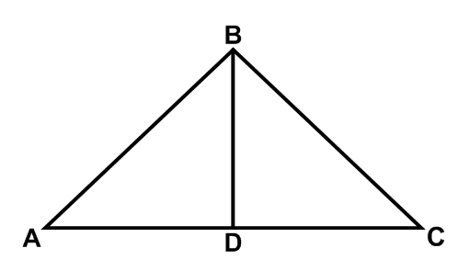Given: , *D* is the midpoint of 

Prove: 

